

BRIAN EVANSON MUHORO

PROFESSIONAL SUMMARY
A highly motivated Social Work graduate with versatile experience in sales, customer service, administrative roles, and IT-based solutions, including CCTV installation. I bring strong communication, organizational, and counseling skills, with a proven track record of excelling in both individual and team settings. My experience spans child welfare, trade development, telemarketing, and field sales roles at Moonsun International and Haosail Machinery Ltd. I am committed to achieving organizational goals through professional integrity, dedication, and a customer-first approach.

PROFESSIONAL EXPERIENCE
Haosail Machinery Ltd Field Sales Representative March 2025 – Present

Rolesandresponsibilities:

- Managing client accounts and driving sales growth in assigned territories.
- Providing product demonstrations and technical support to prospective customers.
- Collaborating with the sales team to develop effective market penetration plans.

Moonsun International
Field Sales Representative

November 2024 – February 2025

Rolesandresponsibilities:

- Executed direct sales strategies in the field, increasing customer acquisition and retention.
- Built and maintained strong client relationships to meet sales targets.
- Conducted market research to identify potential business
opportunities.

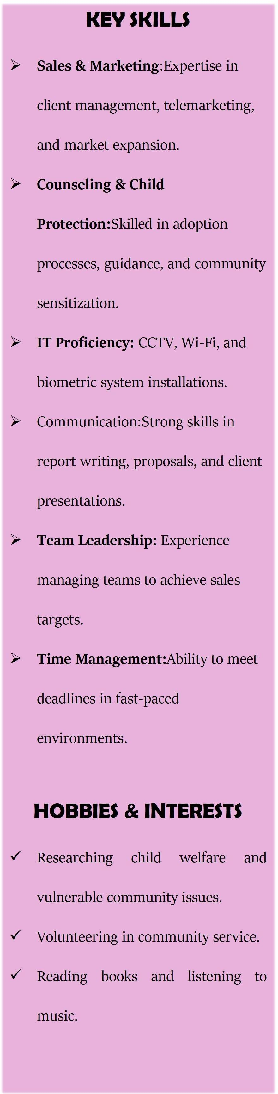
Sales Executive Texplast IndustriesLimited (PackagingIndustry)
May2024 - O c tober 2024

Roles and responsibilities:
- Conducted market research to identify selling possibilities and customer needs.
- Actively sought new sales opportunities through cold calling, networking, and social media.
- Set up meetings with potential clients and delivered presentations on products and services.
- Negotiated and closed deals while handling customer complaints or objections.
- Collaborated with team members to achieve better sales results.

SalesTeamLeaderSipand SnipBarbershop February2024–April2024 Rolesandresponsibilities:
- Led a sales team to execute marketing strategies and increase sales.

- Managed both field and online marketing campaigns for shop products.
- Collaborated with team members to meet and exceed sales targets.

SalesRepresentativeMspace SolutionsLtd
October2023–January2024

Rolesandresponsibilities:
- Conducted telemarketing and cold-calling to generate client leads.
- Presented product proposals to prospective clients and followed up on leads.
- Conducted market visits to explore new business opportunities.


TradeDevelopmentRepresentativeBacardi-MartiniAfrica(NanyukiRegion) May2022 – August 2023
7. Emmanuel khamala Moonsun International Sales Representative,
TeamLeader
+254 703 908890

Rolesandresponsibilities:
- Expanded regional market and improved sales strategies in collaboration with the sales team.
- Conducted customer research and gathered key sales data for market analysis.
- Built and maintained relationships with clients to drive sales growth.
- Managed product merchandising and shelf arrangement across various outlets.
Cashier&SalesAgentBalozi WinesandSpirits October2021–May2022 Rolesandresponsibilities:
- Processed transactions and provided excellent customer service.
- Promoted products to customers to meet sales targets.
- Conducted product research to identify key selling points for alcoholic brands.

CCTV&ITTechnicianQuickstart- AfricaLimited
May2020–December2020

Rolesandresponsibilities:
- Installed CCTV systems, Wi-Fi networks, biometric systems, and solar panels.
- Set up sound systems and telephone networks for corporate and residential clients.
Guidance&CounselingIntern ThikaMainPrisonNovember2018– January2019 Rolesandresponsibilities:
- Provided counseling to inmates on behavioral change and addiction.
- Assisted clients and visitors with inquiries and coordinated visits.

Social Work Intern ChildWelfare SocietyofKenyaMay2017– September2017

Rolesandresponsibilities:
- Coordinated child adoption and foster care processes.
- Conducted home assessments and follow-ups on child welfare cases.
- Led community sensitization programs on children's rights and adoption procedure

